Lab 5 Texturing

Download the zip file, containing the SOIL library (all test textures), from Blackboard. Extract the files into the project directory. Open the Project Properties, navigate to *Linker*, then *Input*, at the top “Edit” the additional dependencies. 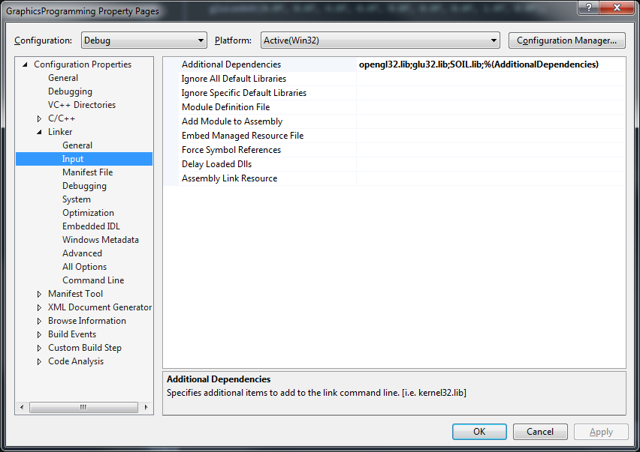  
With the pop-up add “SOIL.lib” to the list of libraries.   
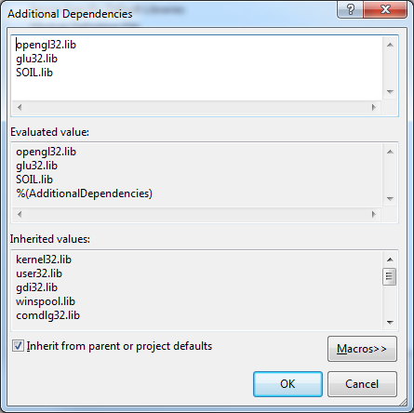

1. Using the code provided in the lecture, the SOIL library and images provided on Blackboard create a textured quad similar to that shown in the lecture. Use the **cratearrow.png** provided in the gfx folder. If the texture coordinates are correct, the arrow should point upwards.
2. Create a second textured quad, create and apply your own texture. This quad should be created using two triangles. Your scene should now contain two quads with different textures.
3. Using the “triangle.png” provided render a triangle and map only the blue half of the texture to it. It should look similar to this:  
   
4. Change the colour of the geometry for one of your quads (try different colours) note the effect. This should blend with your texture as shown in the lecture.
5. Build a cube and texture it to look like a Rubix cube.
6. Add another (or reuse) a textured quad to your scene. Modify the U, V coordinates from 0 to 1, so they are 0 to 2.
   1. Set the texture parameters to repeat the texture.
   2. Update the texture coordinates of the quad so the texture is repeated 3 times horizontally, but only once vertically.
   3. Update the texture coordinates to repeated the texture 4 times both horizontally and vertically
   4. Set the texture parameter to Clamp the texture.
7. Create an application to demonstrate different texture filtering settings. For the example in the lecture I was rendering a 100 by 100 quad. The texture was set to repeat, to cover the shape. The artefacting with be easier to see if the shape is near the camera and/or moving (side-to-side or rotating slowly). Use the textures provided (checked.png and grass1.png) and test the following texture filter settings
   1. Point sampling
   2. Bilinear sampling
   3. Trilinear filtering (requires mipmaps to be generated)
   4. Point sampling on near/magnify and trilinear on far/minify